How to Handle and Submit Signed DocuSigns in BWIC
Brightway Insurance
2022

Contents

EM PL DocuSign 1
No Loss Statements and EM PL NO LOSS 1
Emailing and Uploading Signed Forms to the Carrier 2
Creating Document Upload (Website) Activity in AMS 3
Creating Document Upload (Website) Activity in GUI 5
When Additional Activities are Required 6
If the Form Requires Additional Signatures 8

EM PL DocuSign

In the Email System, BWIC (Brightway InContact), you will receive signed DocuSigns to process in the skill EM PL DocuSign:
This skill is for documents that were signed and received from the customer via DocuSign. The different types of signed DocuSign forms you will receive include the following:

- No Loss Statements
- Change Requests
- Occupancy Forms
- Wind Mitigation Inspections (See Wind Mitigation Guide)
- Coverage Selection / Rejection Forms
- EFT/Payment Authorization Forms

How would these requests be worked? You would first locate the policy and research what the document is for. It could be a change request or signed exclusion form. Determine the carrier as well as how they prefer to receive documents (reference the Carrier Profile in the Wiki). You may be uploading it to the carrier’s site, or emailing it in. Lastly, attach it to AMS. Make sure to follow your checklists in the Outplex Service Manual under Automatic Changes on the Website to determine if a suspense will still be needed for follow up after the document is submitted.

No Loss Statements and EM PL NO LOSS

This skill is used to receive No Loss Statements that are needed to reinstate a policy. You will not be in this queue but there are steps below to take in case you receive a Signed No Loss Statement in BWIC.

  - NOTE: These documents must be processed the same day!

These usually go to a specific queue, so rarely will these be received in assigned skills. When received, send to the EM PL NO LOSS skill. Then, send an email to your supervisor with the details of the email (policy number and name of the insured). This will allow them to notify our processing team as these documents are very time sensitive.

Emailing and Uploading Signed Forms to the Carrier

Below are instructions on how to handle all signed Documents that aren’t No Loss Statements. Each signed document must be uploaded or emailed to the carrier. Later sections will go through whether an additional activity (i.e. Change Limits, Change Credits, Change Customer Info) is needed.

- In BWIC, locate the customer using the Customer Search function.
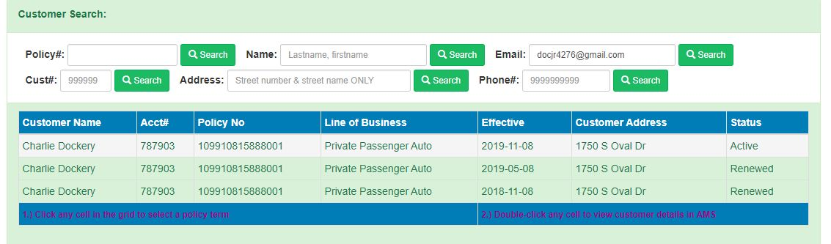
- After opening the signed document and confirming the received DocuSign is a Signed Request form, use the dark blue Email button to drop the email into AMS.
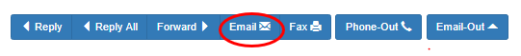
- Follow the preferred method of the carrier (per the carrier profile) to submit the inspection per one of the following:
        - If the carrier prefers documents to be uploaded, upload the completed Inspection form via the carrier website & create a Website activity from the existing suspense. Follow the instructions on from the section Creating Document Upload Activity. I
        - If the carrier prefers documents to be emailed, email the Signed form to the carrier and create the Email activity. Complete the open suspense notating that the inspection form was submitted via Email. If there is an open suspense, complete the open suspense notating that the Signed form was submitted via Email.

- Attach copies of the documents to your Website activity or Email activity and use the corresponding doc type.
Website Activity Attachments:
Email Activity Attachments:
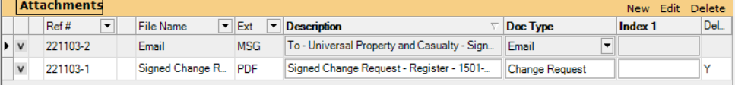
- Click OK
- Click Save & Close to exit the Activity / Suspense window.

Creating Document Upload (Website) Activity in AMS
- Locate customer in AMS.

- Highlight policy in Policy View

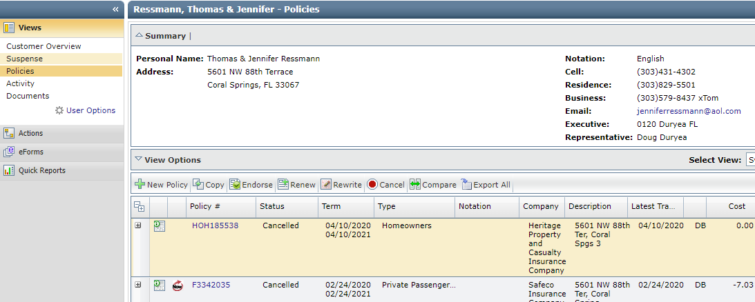
- If there is an exisiting suspense, you may update the activity on the suspense using the steps below. If there is not an existing suspense, use the steps below to create a new activity.
- Create the activity.
  - Action: Website
  - Description: use the Doc Upload Website template in the Customer Service Activity Templates
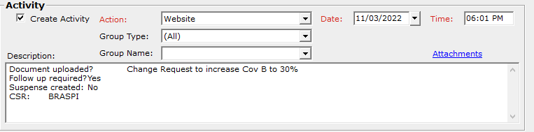
- Fill in the Document uploaded field with the appropriate information.
        - When uploading the document to the carrier, if the carrier does not allow the change to be automatically processed on the carrier website, select No for Follow up Required and n/a for Suspense created.
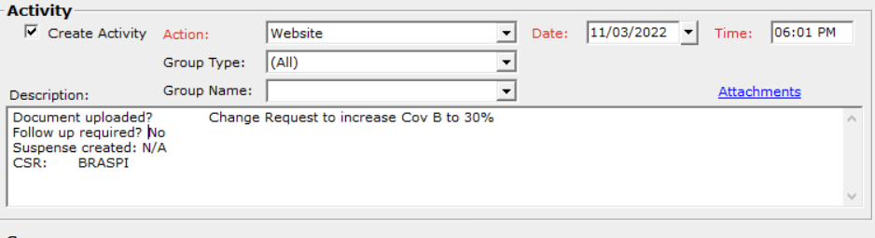
        - If the change cannot be immediately processed and immediate proof generated by the carrier, select Yes for Follow up required and Yes for Suspense created. If there is already a suspense created, there is no need to create a new one and you can select No.
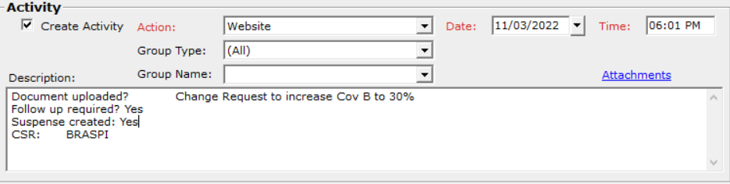
- If the change could not be automatically processed, a follow up is required. If there is an open suspense, push it out 5 days with an action code of Change confirmation. If there is not an open suspense, create one and push it out 5 days with an action code of Change confirmation. Make a note stating “Please confirm _________ has been processed.” In the above example, the verbiage would read “Please confirm the request to increase Coverage B to 30% has been processed.” Set the suspense to Personal Service.

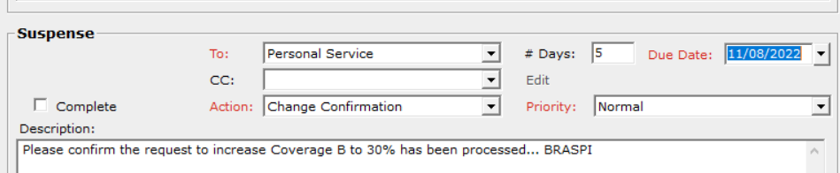
- Click Save & Close to exit the Activity / Suspense

Creating Document Upload (Website) Activity in GUI
      - Locate the Customer in GUI.
      - Select the Doc Upload / Website Template.
      - Fill in the Document uploaded field with the appropriate information.
        - When uploading the document to the carrier, if the carrier does not allow the change to be automatically processed on the carrier website, select No for Follow up Required and n/a for Suspense created.

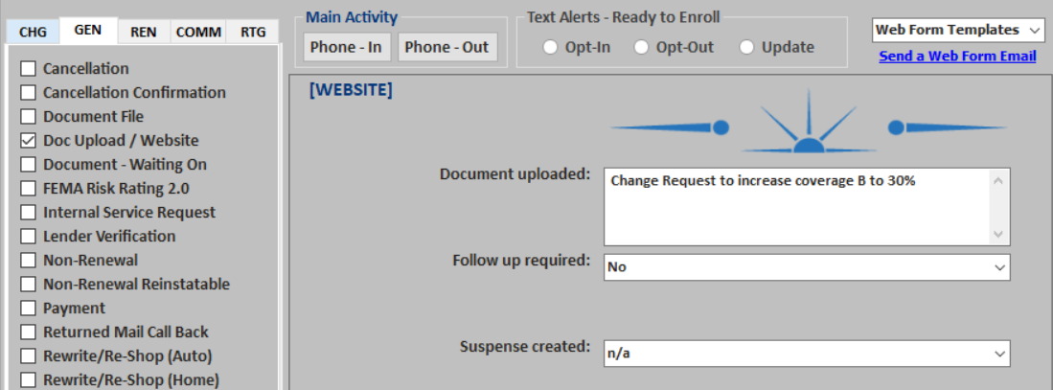
        - If the change cannot be immediately processed and immediate proof generated by the carrier, select Yes for Follow up required and Yes for Suspense created. If there is already a suspense created, there is no need to create a new one and you can select No.
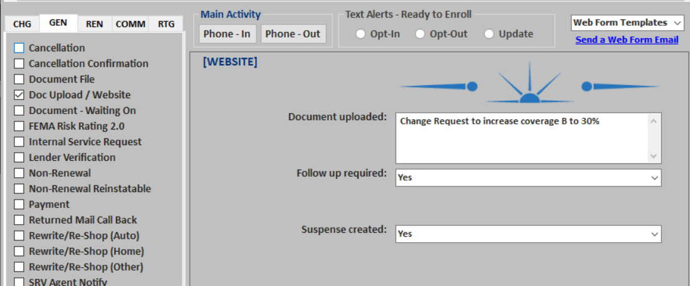
      - If the change could not be automatically processed, a follow up is required. If there is an open suspense, push it out 5 days with an action code of Change confirmation. If there is not an open suspense, create one and push it out 5 days with an action code of Change confirmation. Make a note stating “Please confirm _________ has been processed.” In the above example, the verbiage would read “Please confirm the request to increase Coverage B to 30% has been processed.” Set the suspense to Personal Service.

When Additional Activities are Required

Determine if the Signed form requires a Change Activity template in addition to the Email or Website activity. Below are the different types of changes and their related Change activities. You can manually create the activity in AMS using the Customer Service Activity Templates on the Wiki or on GUI under the CHG tab.

Change Requests and Coverage Selection / Rejection Forms

- Coverage Only Change Template
(Action Code: Change Limits) – If Changing Auto Policy Limits
- Other Changes Template
(Action Code: Change Limits) – If Changing Homeowners Policy Limits
(Action Code: Change Deductible) – If Changing Deductibles
(Action Code: Change Additional Coverages) – If Changing Additional Coverages
- Vehicle Change Template
(Action Code: Change Vehicle) – If Signed Request is to backdate a vehicle Removal
- Driver – Remove Template
(Action Code: Change Driver) – If Signed Request is to remove a driver

Occupancy Forms

- Customer Information Template
(Action Code: Change Customer Info) – The action code will automatically default if using GUI. Use this template if changing the insured’s name, email address, phone number, or any other basic personal information.
- Address Change Template
(Action Code: Change Customer Info) – The template in GUI is Address Change, but the action code will default to Change Customer Info.

Wind Mitigation Inspections

- Change Credits Template
(Action Code: Change Credits) – If there is a premium bearing change due to a change in credits on the policy.

EFT / Payment Authorization Forms

- Change Pay Plan Template
Action Code: Change Pay Plan

      - If there is no suspense open, start a new activity. If there is an existing suspense open, update the Activity on the suspense:
  - Action: Ex. Change Limits (or appropriate Change Action option)
  - Description – use the “Changes” template

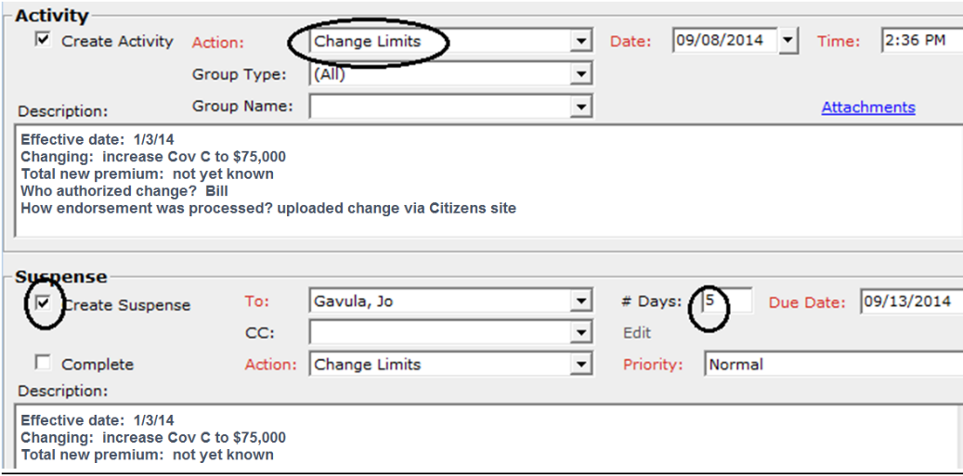
- Click Save & Close to exit the Activity / Suspense.

If the Form Requires Additional Signatures

If the form received is incomplete, we will need to open the DocuSign and re-send it to the insured for total completion. All appropriate signature fields and dates must be filled in.

- Open the unsigned form.

- Save to the desktop, name it using the following format:
  - Example: Change Request – Insured’s Last Name – Policy Number

- Login to the DocuSign website.

- Follow DocuSign procedure and send the form for signature and date.

- Update the Activity:
  - Action: Change to Email
  - Description: Use the “Email-Fax” Activity/Suspense template & notate that it was sent via DocuSign.

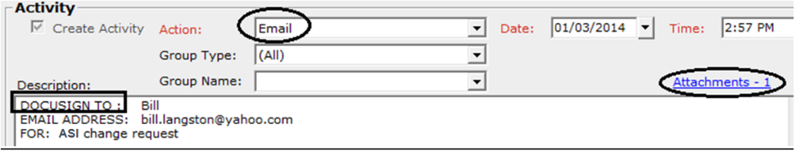
  - Click Attachments (there will be only 1).
    - Example: “To Bill: unsigned change request via DocuSign”

  - Click OK.

NOTE: No change can be processed until the customer’s signature on the appropriate form is attached to the customer file in AMS360.

- If there is no suspense open, start a new activity. If there is an existing suspense open, update the Activity on the suspense:
- Action: Waiting on Document(s)
- Description – use the “Waiting on Docs” template
- Click Create Suspense (push the suspense 3 days)

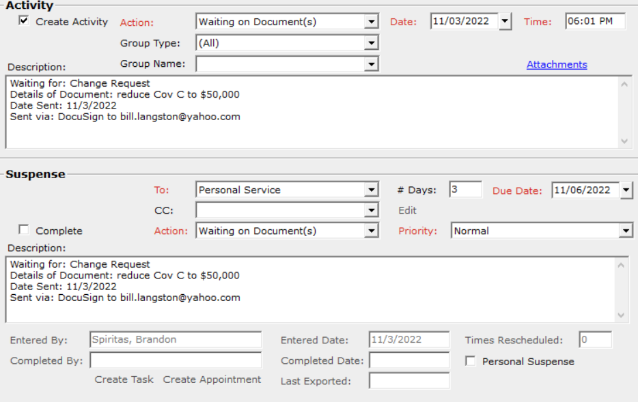

- Click Save & Close to exit the Activity / Suspense window.

